syntax

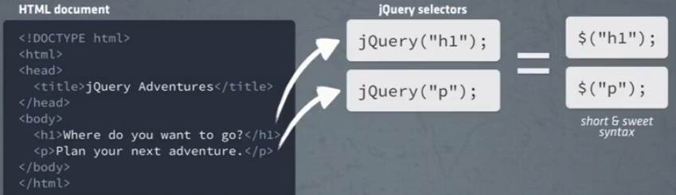

Ready?

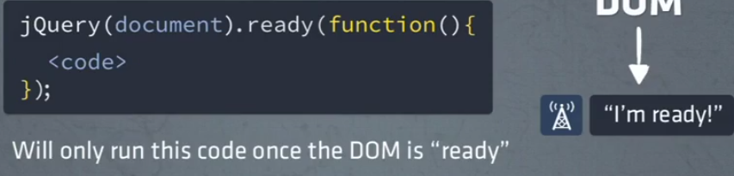

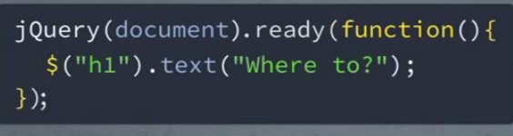

Include

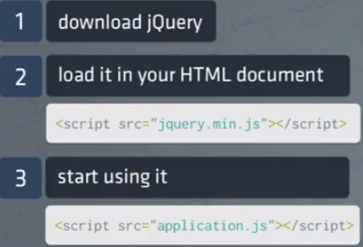

Select „id“

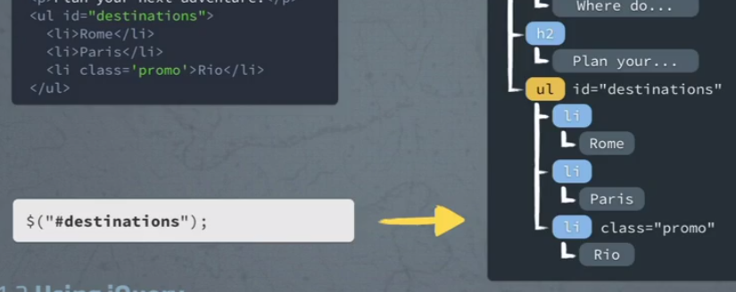

Select „class“

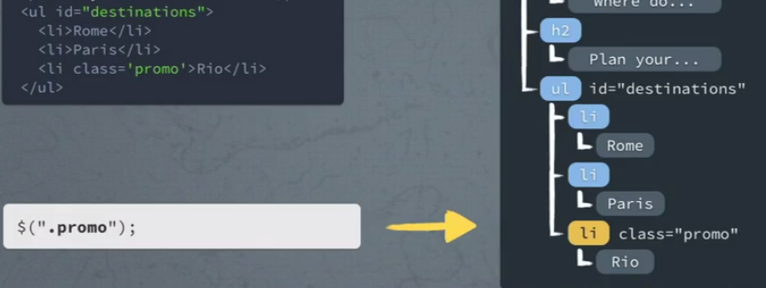

Descendant

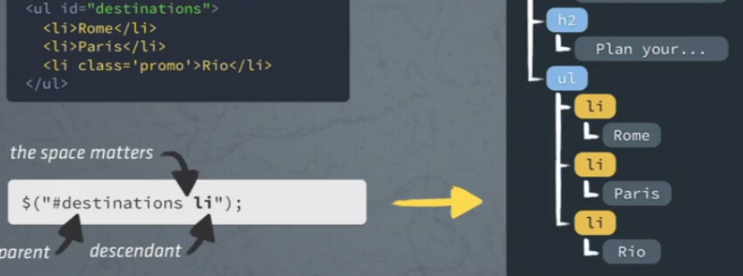

Only direct children

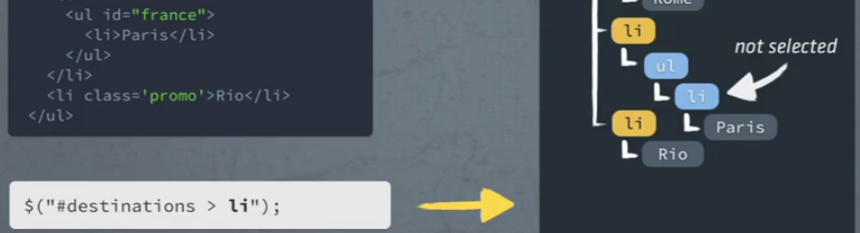

Filters

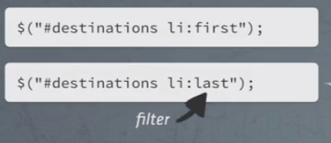

Striped list



Traversing

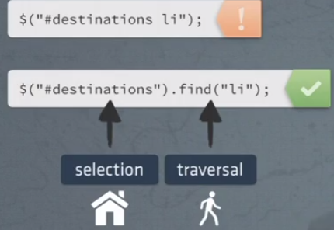

.prev, .next, .parent, .children, .find (direct <-> all desc)

Append 1 -> correct var

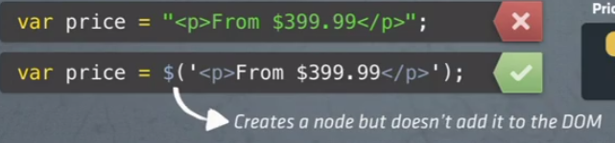

Append 2 -> to the DOM

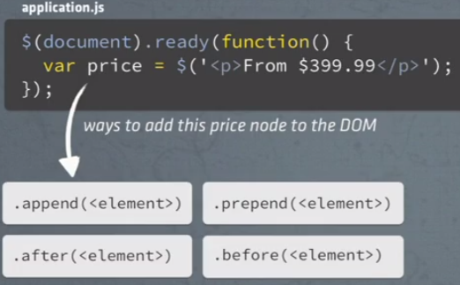

Append 3 -> different order of syntax

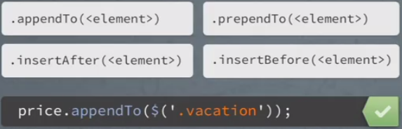

Summary: Create + Append (+ Remove Button)

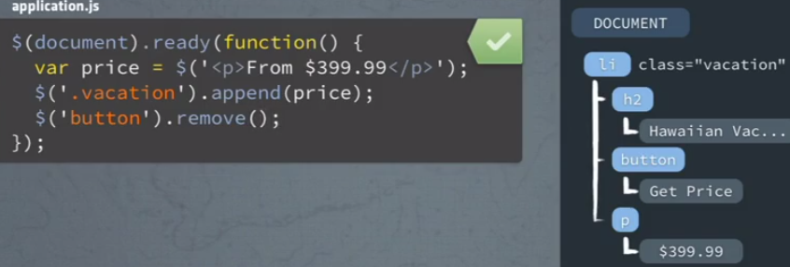

[Append in angular]

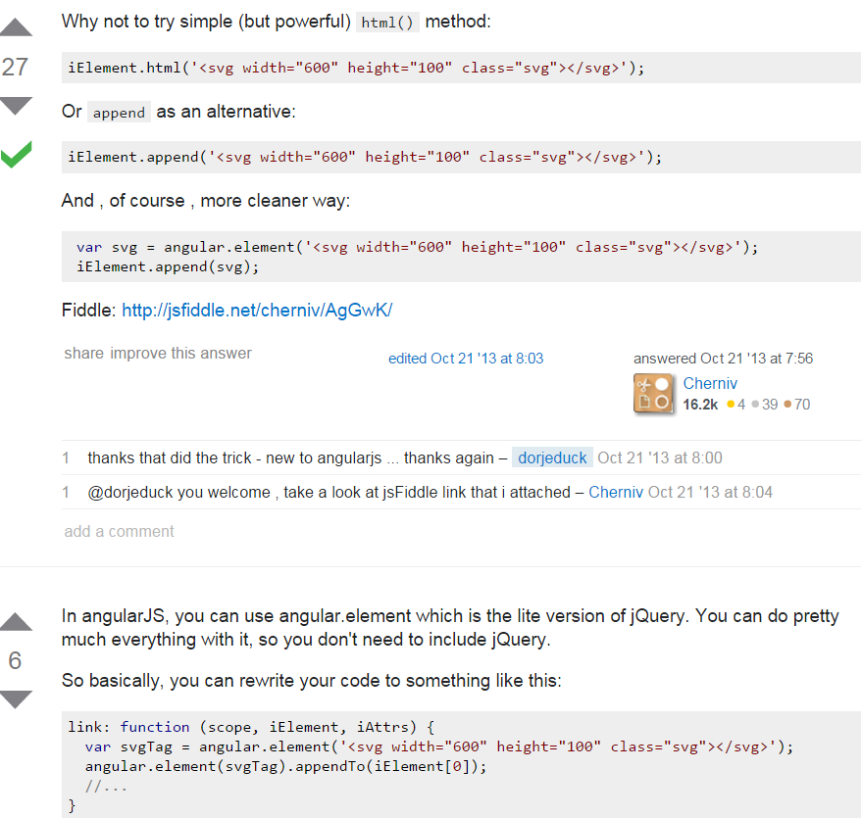

Event loop & event handler  
1) event loop -> by browser -> callback  
2) callback function -> provided via document.ready()

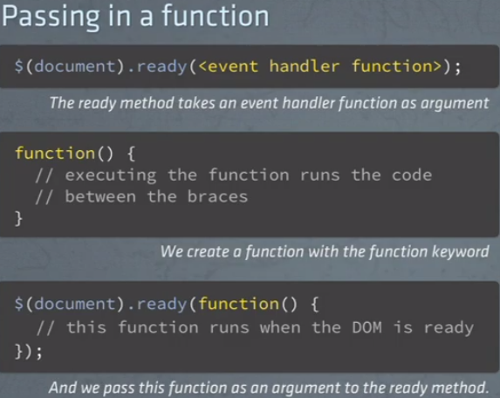

Event + handler

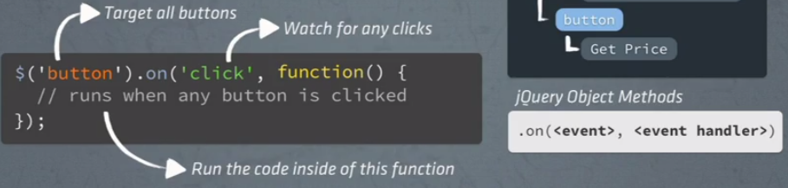

Summary:   
1) event loop callback  
2) event handler  
3) DOM manipulation  
[angularis -> controller on <p> + handler in controller + ng-click on button]  
[cleaner -> html-button -> knows its handler]

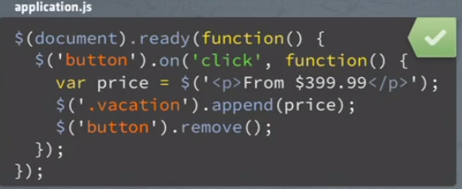

Particular element & as jQuery object required …

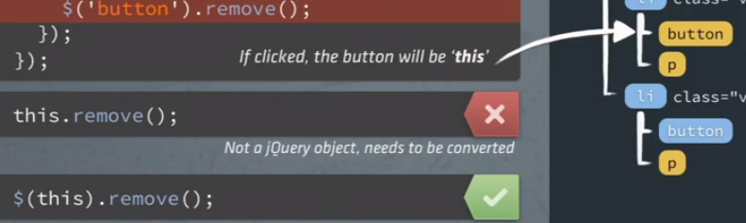

Don’t add price after every button -> just the one, that triggered the <event>

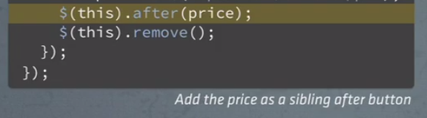

Tricky: un-noticed <div>

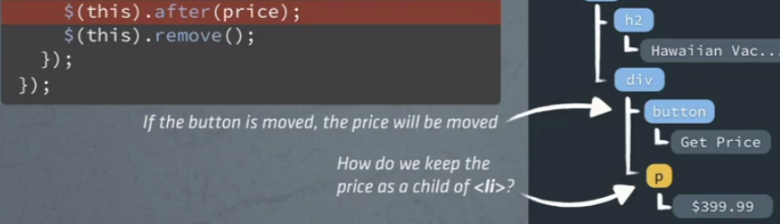

Neat: closest() -> traverse up the tree

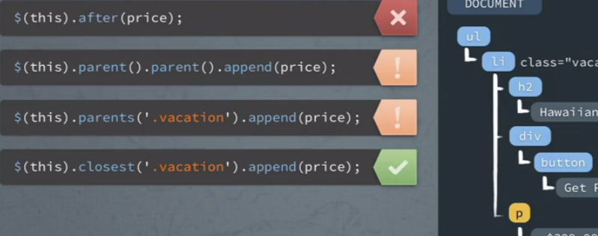

Summary:

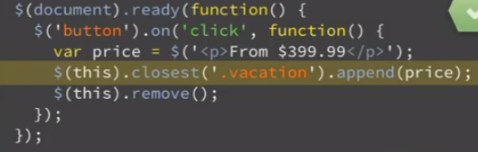

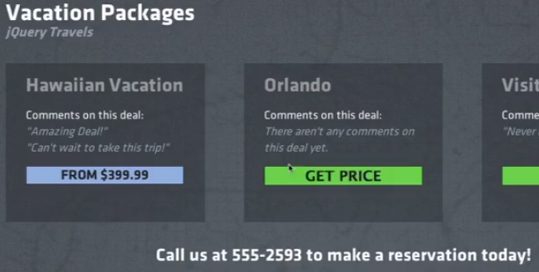

Data-Attribute -> make data available via Html (prefix „data-„)  
[angular alternative -> have controller access Json structure]

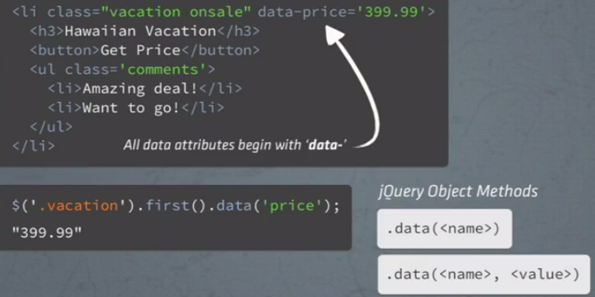

Usage

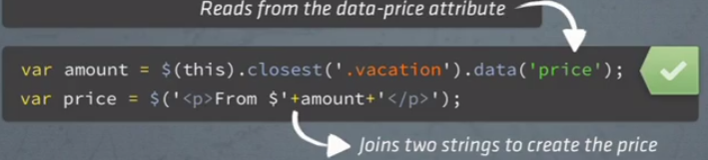

Refactor

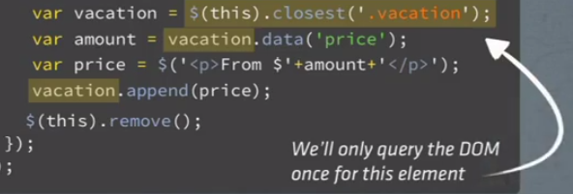

How to identify button -> by class of parent + element (not ID (!!))

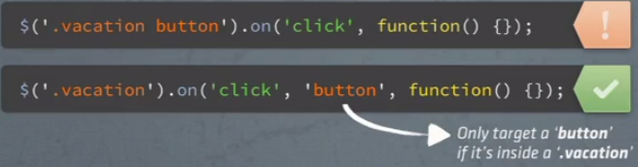

Filter & Highlight -> look for class (info data) & add a class (CSS highlight)

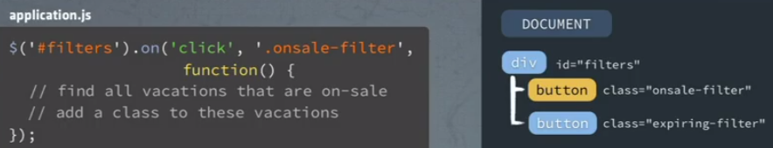

Syntax -> filter

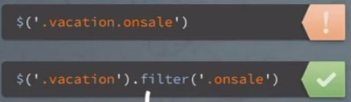

Summary: class filter + class manipulation

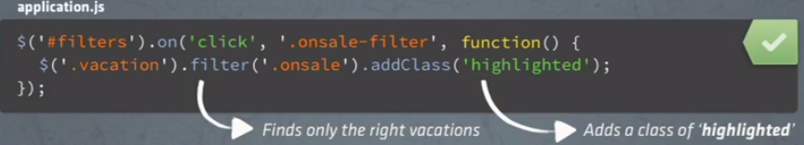



-----------  
-----------  
Level 4  
show element only after button-click

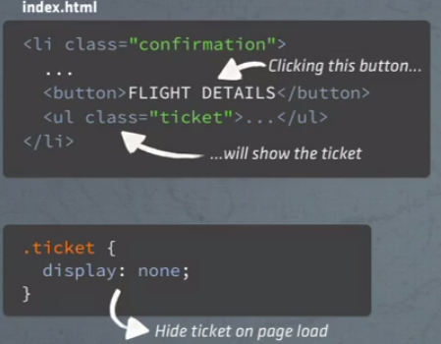

Code:

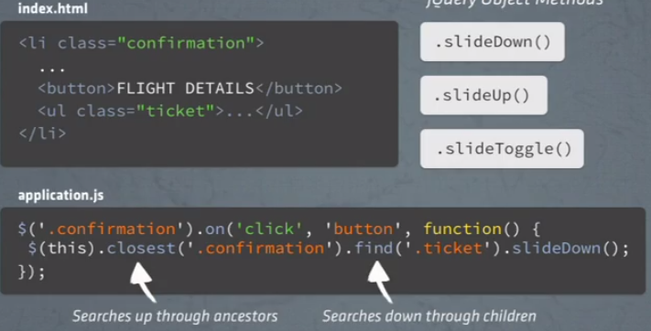

Debug:

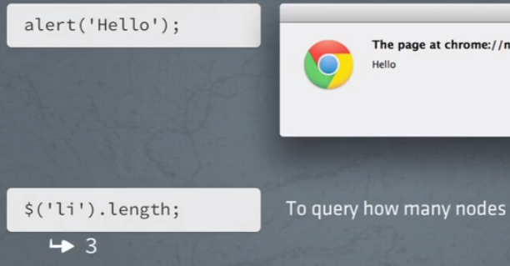



Example -> toggle

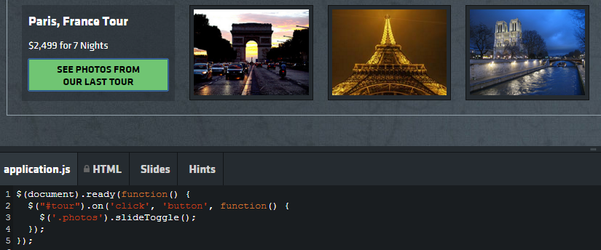

Mouse events -> „tooltip“

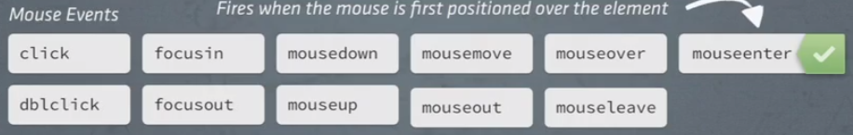

Refactor -> function out of handler -> function pointer [i.e. no parantheses]

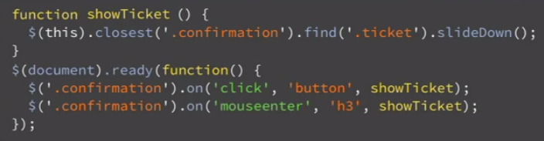

Show and hide -> pics + caption

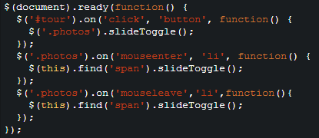 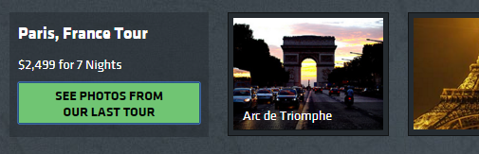

Input element

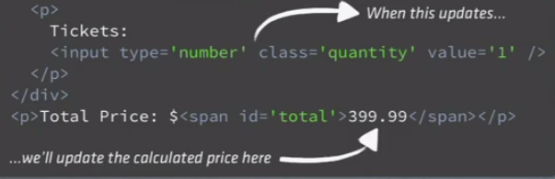

Keyboard events

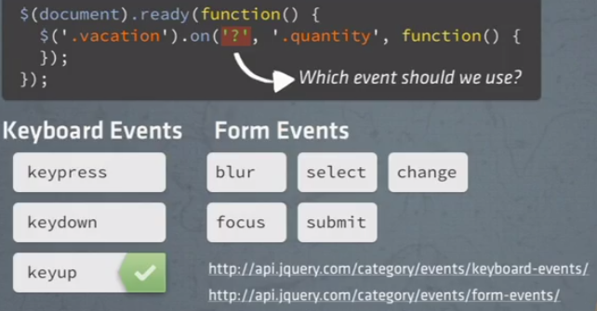

String to number

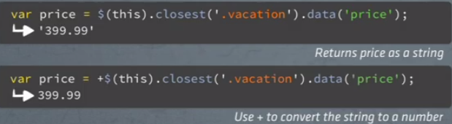

Update field based on quantity change

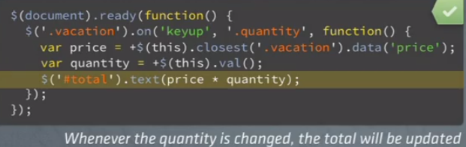

On <event> -> page jumps to top -> prevent with -> „stopPropagation“  
1) pass arg (event)  
2) do not put focus on all parents

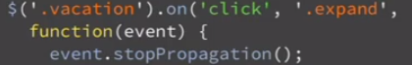

… but the problem was the browser -> keep it out of the loop

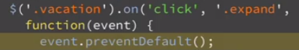

---------------  
---------------  
CSS -> function + chaining + jquery object

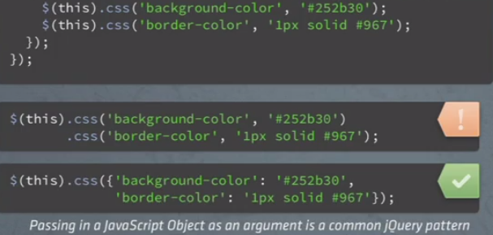

Switch between -> display:none + display:block

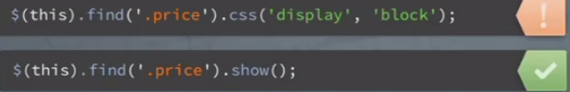

Move CSS code to style-sheet

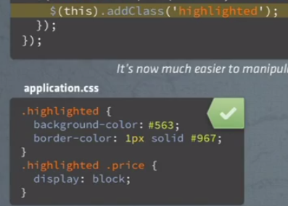

Usually -> toggle („on-click“)

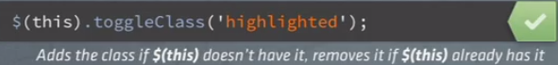

OR: Highlight on enter & un-highlight on leave

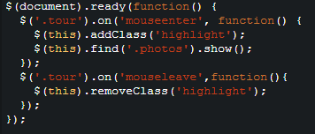

Animate -> move slowly (visible)

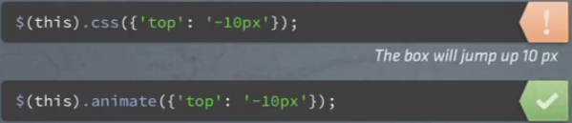

Up and down, depending on „has-class“

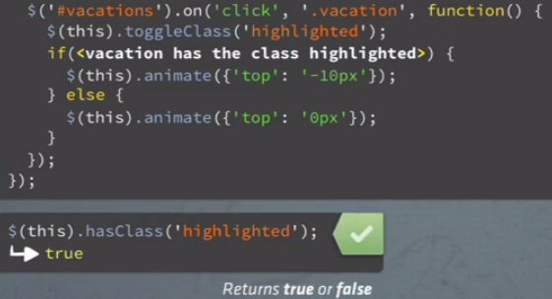

Change speed (fast, slow) -> default 400ms

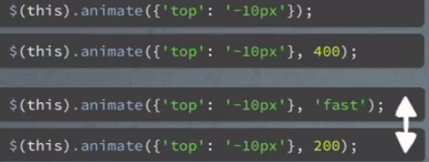

Refactor to CSS

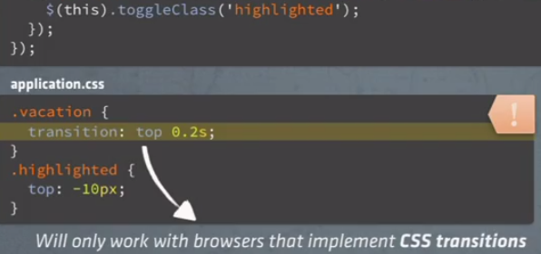

Browser-specific implementation

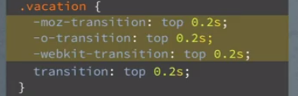

-----------------  
-----------------  
-----------------

Ajax -> retrieve Html snippet

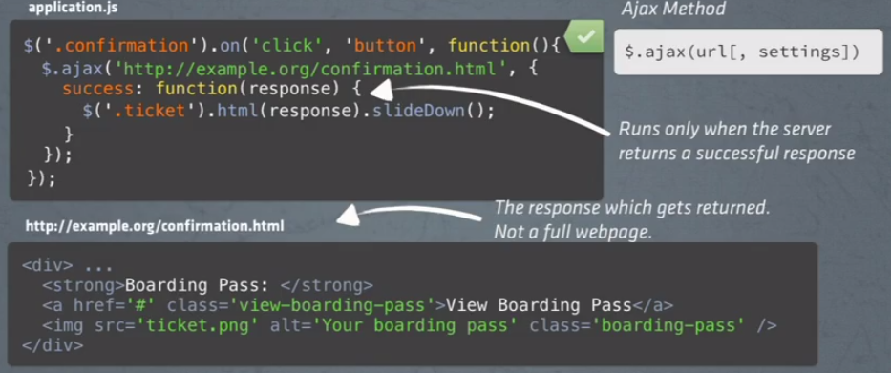

Shorthand (ajax + success)

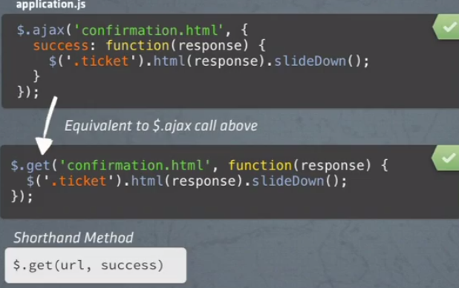

Params

